Green Wine Future Summary
Green Wine Future 2022 was a global virtual wine industry conference held over four days in late May. The ambitious event featured a line-up of 16 keynote addresses, 24 sessions, and 170 presenters from five continents focusing on the wine sectors’ most pertinent sustainability issues. Topics ranged from regenerative agriculture, climate change and water security, to corporate responsibility and greenwashing to name a few.
New Zealand Winegrowers was the host organization for the fourth day. Barossa Australia, Wines of Chile, Wines of California, Wines of South Africa, Wines of Portugal, Interprofesional del Vino de España, and Cave de Gan Jurançon (France) hosted the previous three days.
It was an exhaustive programme – the most ambitious of its kind – so we have summarised some take-away messages of speakers from the New Zealand wine industry below.
Anyone wishing to view conference replays can do so until the end of June 2022 by purchasing access for $45 USD at http://www.greenwinefuture.com . NZ members have been granted a 55% discount using code NZWINE55

Day 1.
Day one’s host region was Latin America (in associate with Wines of Chile).
Yealand’s Michael Wentworth presented during a session entitled Green House Gas Emissions: Indentification, Education, And Mitigation. Michael (who also sits on the Board of International Wineries for Carbon Action) spoke about their company’s milestone of being the first winery in the world to be carbon zero from inception.
He stressed the importance of gaining not only buy-in from top management as an essential first step in any company’s carbon management journey, but also embedding sustainability throughout the entire staff culture. This is achieved at Yealand’s through engagement activities and incentives from the very start – sustainability metrics are now linked to people’s professional performance KPIs for example.
Michael also spoke of the company’s shift from relying on external consultants to drive carbon reduction, to bringing the work in-house. A key learning during this process was the increase in buy-in amongst staff that came about from the work being driven from within. His call to action was to ensure that staff team really own the carbon reduction journey.
Michael rounded out his presentation with a call to wineries to join the IWCA.

Day 2
Day two’s host region was Africa (in association with Wines of South Africa). A panel discussion on Biodiversity and the Vineyard of Tomorrow included National Vineyard Manager for Craggy Range, Jonathan Hamlet who spoke of the need for creative solutions to offset negative soil health impacts associated with monocultures.
Jonathan described a trial run by Craggy Range around the use of native species for under vine planting and their potential to support soil microbiome health. He discussed how the selection of species needed to meet multiple criteria, including being maintenance free and not causing de-vigor to the vines themselves.
Jonathan spoke of the success of the project through the trial stage, and the current challenge ahead of them to ensure the plants can be easily propagated in order for the project to be scaled successfully.

Day 3
Day three’s host region was Spain (In Association with Interprofesional del Vino de España).
First up on day 3 was a session entitled Wine Grapes In A Changing Climate. Darrell Lizamore from the Bragato Research Institute spoke about their Sauvignon Blanc Improvement Programme which aims to accelerate grape vines’ natural ability to adapt to a changing environment.
The research involves taking grapevine material from the vineyard and exposing it to a brief period of stress in a controlled environment. This stress triggers the plants innate response to environmental stress and it starts to naturally accumulate new diversity. When the stress is removed, the process stops, locking in those new changes. New Sauvignon Blanc vines can then be grown from this material, without the introduction of foreign DNA or being bred with a different variety. As the vines grow, they become a new collection of diversity.
The next stage of the project is to screen these vines for traits of potential benefit to the NZ wine industry. Currently, traits that require reduced inputs of sprays and water, those which increase productivity and those that lead to interesting new wine styles are being prioritized for further propagation. The new collection of genetic diversity can also be tapped into to respond to future challenges.

Belinda Jackson from Lawson’s Dry Hills also spoke of their company’s long-held history of sustainability leadership. The company is the only NZ winery to hold both ISO 14001 certification for environmental management and ISO 14064 carbon zero status.
Based on the underlying principle of continuous improvement, Belinda described how ISO 14001 certification has Lawson’s Dry Hills firmly committed to the efficient use of resources, reduction of waste and careful management of all relevant environmental issues, such as air pollution, water and sewerage issues, soil contamination and climate change.
Decades of commitment to low impact operations has resulted in impressive results including energy use per litre of wine being 37% lower than the industry average for wineries of equivalent size and water use per litre of wine 57% below the industry average.
Belinda noted the importance of independent auditing to bring credibility to claims and its usefulness in providing assurance to export partners and other stakeholders.
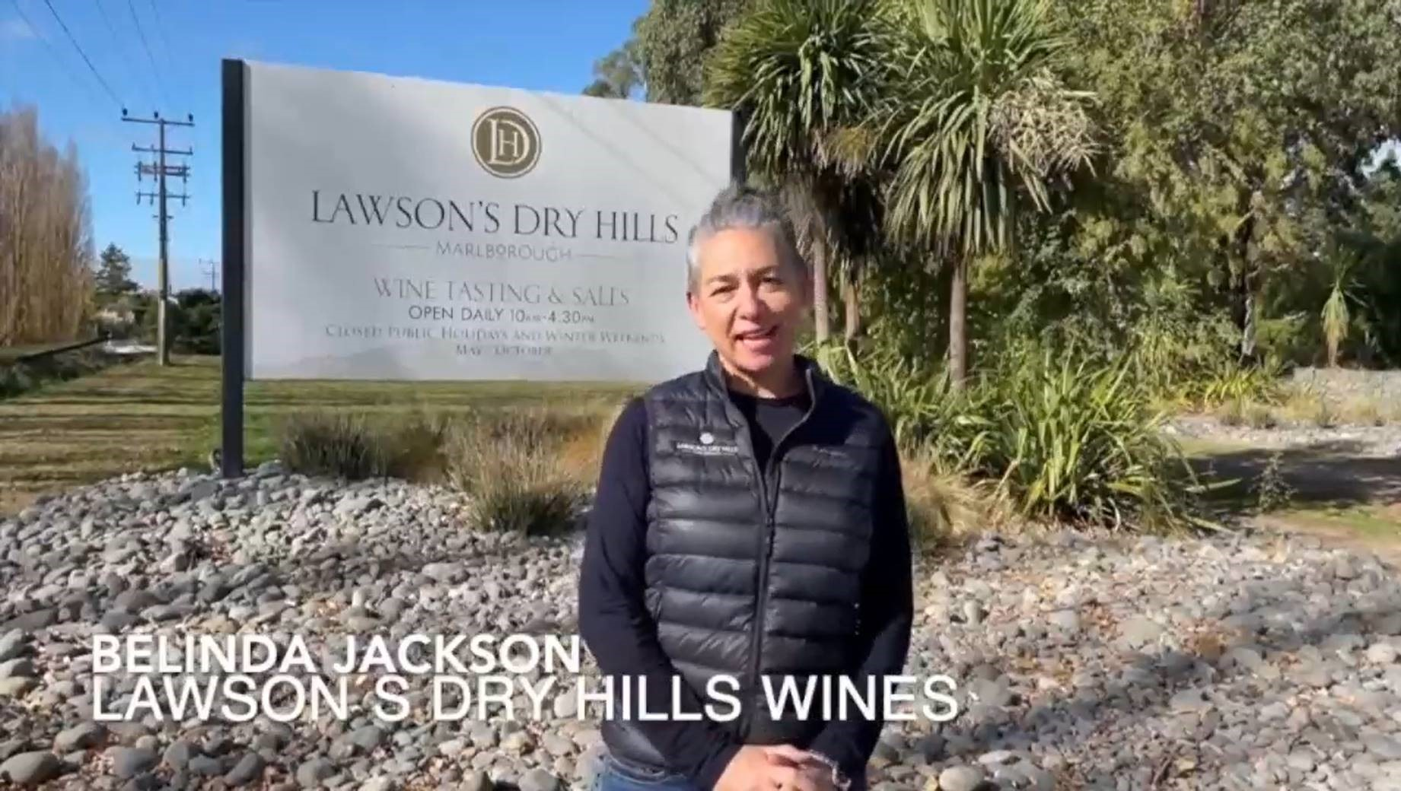

Day 4
Day Four’s host region was Oceania (in association with New Zealand Winegrowers).
The day began with welcome speeches from NZ Minister of Agriculture Damien O’Connor and New Zealand Winegrowers GM of Marketing Charlotte Read.

Dr. Edwin Massey NZ Winegrowers GM of Sustainability spoke on the panel entitled ‘Navigating The Waters Of Government Policies’. Two clear themes to emerge from the suite of speakers across the globes wine industries were:
- Water security and climate change are the most urgent environmental issues being addressed between governments and primary sectors
- The importance of primary sectors – including grape and wine industries - to demonstrate leadership on these issues and inform the design of government policy from the ground up
Dr. Massey spoke of the NZ wine industry’s strategy of demonstrating their commitment to sustainability namely through investment in their data collection and certification programme Sustainable Winegrowing NZ (SWNZ). He noted the value of data transparency as a mechanism to build trust between industry and government.
Dr. Massey noted that the collection of industry wide data on sustainability performance is a crucial component of government engagement and plays an important role in ensuring policy decisions accurately reflect the risk – or lack thereof – of wine industry activities.

Nigel Greening from Felton Road presented on a feature entitled The Value of Organic And Biodynamic. Nigel noted that while Felton Road is certified organic and biodynamic, he believes caution is required around falling into any particular entrenched positions in terms of how to care for the land, environment and people. His call to action is to question dogma and labels – hybrid approaches are needed as there is no one ‘correct’ route or solution.
Nigel believes that regenerative agriculture has the potential to build bridges between different cultures of sustainable thinking such as organics, biodynamics and controlled chemical use.

Steve Smith M.W. the Managing Director of Aotearoa New Zealand Fine Wine Estates spoke in one of the final sessions, entitled What Is Regenerative Viticulture?
Although Steve and his team practices organics and biodynamics, he does not believe these systems are fit for purpose in terms of addressing today’s challenges. To Steve there is no value in the myriad certification schemes available on the market now, if the schemes themselves do not genuinely address the issues we are facing, namely: a demanding, fragile climate; stressed water systems and biodiversity in peril.
The answer he believes, lies in science and natural wisdom coming together and working side-by-side in a more intuitive way. This science, he argues, must not be reductive, but rather organic, fluid, creative science. He stressed that what matters are outcomes, not inputs.
Steve spoke to the ‘regenerative mindset’ and described a logic model that his team are putting into place as the way for their business to think about regenerative production systems. The model is based on the following concepts:
- Reconciliation
- Repair
- Repopulate
- Regenerate
- Review
- Renew

